Cleaning and Maintenance Information

Accessories

Flexible PVC Stair Edgings
Data Sheet: (sheet 1 of 2) October 2015 KRO/LB

This leaflet has been compiled to help the user obtain optimum performance and satisfaction from their selected product:

Preventative Maintenance Programme

A regular scheduled maintenance programme should be employed to prevent the build up of dirt and grease, which will reduce the anti-slip properties of the channel and detract from the overall appearance of the product.

NB. Under no circumstances should any cleaners containing hydrocarbons, bleach, pine oil or citrus based agents be used to clean any Gradus Stair Edging.
Steam cleaners, power washers, floor sealants, polishes or any coatings should not under any circumstances be used on inserts.

Daily Cleaning

Brush down the channel using a soft bristled brush and remove dust particles from the insert by wiping with a damp cloth.

PVC Channel

Stubborn marks such as boot blacking may be removed from the PVC channel by means of a green scotch pad and suitable detergent. Due to the physical properties of the PVC material, we strongly recommend that the green pad is changed regularly.

Twice Weekly or as Required

Brush down the channel using a soft bristled brush. With clean, warm water, containing the correct dilution of aluminium safe cleaning solution apply a small amount to a well rung out damp mop or a Vileda Padmaster/3M Doodlebug and gently clean the surface of the insert in a left to right motion. During the clean, the water must be changed on a regular basis. Do not soak the insert. Once the stair edging has been cleaned thoroughly rinse with fresh, clean water, making sure as much water is removed as possible

On completion the staircase should not be used until completely dry.

The cleaning methods described for the above mentioned products can be used with other Gradus PVC products.

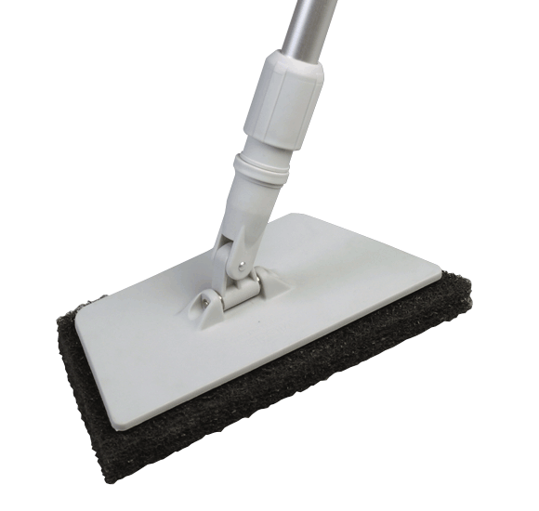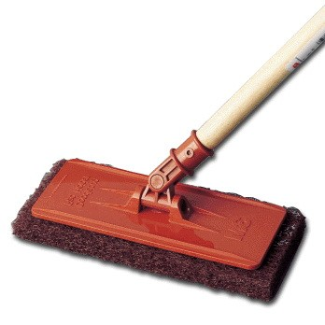


Gradus Accessories, Park Green, Macclesfield, Cheshire SK11 7LZ England UK Tel: 01625 428922 Fax: 01625 433949
www.gradusworld.com

Vileda Padmaster
3M Doodlebug

Flexible PVC Stair Edgings
Data Sheet: (sheet 2 of 2) October 2015 KRO/LB
Cleaning and Maintenance Information
Gradus Accessories, Park Green, Macclesfield, Cheshire SK11 7LZ England UK Tel: 01625 428922 Fax: 01625 433949
www.gradusworld.com

Accessories
Recommended Cleaning Products for Gradus Flexible PVC stair edgings

Gradus has worked with Selden Research to undertake extensive testing on all Gradus stair edgings. As a result, a range of cleaning products has been recommended for use with Gradus stair edgings in a variety of environments.

The cleaning products listed below are suitable for these particular stair edgings.

For further information about these cleaning products, including environment suitability, instructions for use and COSHH data sheets, please contact:
Selden Research Limited, Staden Business Park, Staden Lane, Buxton, Derbyshire, SK17 9RZ.
Tel: 01298 26226
Email: gradus@selden.co.uk
Web: www.selden.co.uk

Product Description | Name | Code | Vinyl Floor Safe
Neutral Cleaners | Neutral Scrubber Drier Detergent | F176 | Yes
Neutral Cleaners | Sabre | C054 | Yes
General Purpose Cleaners | Multi Purpose Cleaner | F010 | Yes
General Purpose Bactericidal Cleaners | Selgiene | C020 | Yes
General Purpose Bactericidal Cleaners | Selgiene Ultra | C066 | Yes
Heavy Duty Alkaline Cleaners | H.D. Degreaser | F052 | Yes
Heavy Duty Alkaline Cleaners | Selclen S | F014 | Yes
Acid Cleaners | ACT | H005 | Yes
Acid Cleaners | Selate | H002 | Yes

